# [About Last Night…GHOSTS, LAW & ORDER: SPECIAL VICTIMS UNIT, LAW & ORDER: ORGANIZED CRIME, and More](https://www.givememyremote.com/remote/2023/02/17/about-last-night-ghosts-law-order-special-victims-unit-law-order-organized-crime-and-more-5/)

February 17, 2023 by [Marisa Roffman](https://www.givememyremote.com/remote/author/marisa/)

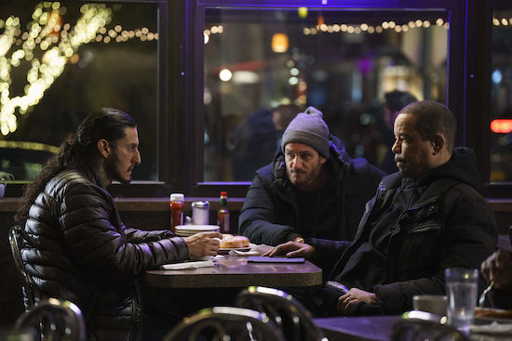

***LAW & ORDER: SPECIAL VICTIMS UNIT — “Dutch Tears” Episode 24014 — Pictured: (l-r) — (Photo by: Peter Kramer/NBC)***

**LAW & ORDER: SPECIAL VICTIMS UNIT:** Easily the best SVU episode of 2023, and—for me—it’s not even close. I missed Olivia, of course, but I appreciated how they played with the format, how it actually felt like a retro SVU hour with a strong guest star showcase (Richard Cabral was great), and that it centered on a survivor getting justice.

I’m also thrilled for Ice that he finally got so much to do. He, arguably, hadn’t really had a bigger episode since season 20—he had big things happen, for sure, but he hasn’t taken the stage like this—and it was nice to get these insights into Fin. (And we got a Munch update! Oh, that made my heart happy.)

And how lovely were the Fin and Olivia scenes? Her speech was beautiful, but even more touching was the private moment they had when she walked him home. They’ve gone through so many changes, but they’ve been working together for over two decades. They’re each other’s constants, and I’m thankful when the show acknowledges how much it means to them.

I will admit to being a little baffled by the choice of Fin’s partner in the episode, though. Don’t get me wrong: I actually love Bruno and think he might be the most seamless/natural entrance into the show since Fin back in season 2. And I know there’s the weird “Velasco may have killed a guy and either Olivia’s keeping him on the team and jeopardizing cases or she knows he’s clean and she’s testing Muncy” subplot that’s going on that impacts Muncy and Velasco. But it’s a bit of a bummer they were MIA—even at his celebration?!*—and it wasn’t one of them who got to work this case with him. And, frankly, it could have allowed bonds to solidify in the team, which has already been so fractured over the past few seasons. (In a perfect world, though, I think I would have loved for this to facilitate Phoebe’s return. She’s a cop, he broke into their home; she absolutely could have been working with him, unofficially.)

*Look, who was at the celebration was uncomfortable. I, truly, don’t know the right answer as to how to handle the awkward missing pieces. Phoebe’s presence needed to be addressed, obviously, but once you mention why Rollins is MIA—and you should given her marriage to Carisi/friendship with Fin—it’s then weird you’re not acknowledging Muncy and Velasco’s absence, even if it was a throwaway line about them working a case or whatever. And even Elliot, who has a friendship with Fin. The room was filled with people we don’t know, despite Fin’s 22-year history with the show. It’s probably a lose-lose situation, but it’s still a bummer.

**LAW & ORDER: ORGANIZED CRIME:** Quasi-echoing what I said with SVU, this was officially the best arc of the season, and it’s also not even close. (Also, once again, [Ainsley Seiger and Danielle Moné Truitt](https://www.givememyremote.com/remote/2023/02/01/law-order-organized-crime-punch-drunk-preview/). My God, they killed it.)

I’m so intrigued to see how Murphy comes back into the mix, because OCCB lost this battle, but there is no way in hell they lost the war; Elliot made that clear. Plus, Ayanna deserves justice for her partner. Maybe season finale time?

On a purely (nerdy) technical note, these mini-arcs, in many ways, are a lot harder than the pods of season 1/2 or the episodic beats of other procedurals. If you’re investing this much into a group of villains, you need to care, but also need to care fast…while also giving insight into the main cast, and somehow delivering a compelling case that justifies multiple episodes worth of real estate. But, again, this worked.

I hope the writers can use this as the figurative blueprint going forward: No, we don’t need to see Jet in danger/undercover, Bell digging into her past, and a human-eating dog in every arc, but we DO need these deeper personal moments for the team members, both alone and individually. We need complex, interesting villains. (Even if we maybe want to punch them in the face a little. Murphy, you’re on my list.)

I know they will have a case to solve next week, but I hope it isn’t entirely business as normal for Bell and Jet…they went through real freaking traumas here. We got the lovely beat at the end where they acknowledged their losses and had to contend with the cards they were dealt, but it would make sense if they were still a little tender as the next case unfolds.

This also may seem minor, but I do hope we get more glimpses of Elliot as a secondary/supporting character. Don’t get me wrong: Chris Meloni is an incredible actor and I love Elliot Stabler. And this isn’t even about my now-frequent plea to stop having him go undercover. More importantly, I also think it’s so important we see him supporting his team after seeing them play that role for him so frequently. Elliot in Fierce Dad Mode when Jet was gone/interrogating Seamus and then quietly encouraging Jet to get therapy post-UC? Gorgeous. EVERYTHING about Stabler/Bell? Yes, please. We know he has her back, but it means so much more when we actually see him show up for her. And, to be a broken record, you saw the performances Truitt and Seiger gave, right? Let us get more of that, too.

And on a lighter note, Whelan and Reyes bickering in the car was laugh-out-loud funny.

So, does that IAB investigation into Bell just go away now, or…?